**Module 1 Bazel**

**1. Bazel installation on windows :**

**Check your system**

Recommended: 64 bit Windows 10, version 1703 (Creators Update) or newer

To check your Windows version:

* Click the Start button.
* Type winver in the search box and press Enter.
* You should see the About Windows box with your Windows version information.

**Install the prerequisites**

* [Microsoft Visual C++ Redistributable](https://learn.microsoft.com/en-us/cpp/windows/latest-supported-vc-redist?view=msvc-170)

**Download Bazel**

Alternatively you can:

* [Download the Bazel binary (bazel-*version*-windows-x86_64.exe) from GitHub](https://github.com/bazelbuild/bazel/releases).
* https://github.com/bazelbuild/bazel/releases/download/7.1.1/bazel-7.1.1-windows-x86_64.exe

### Set up your environment

To make Bazel easily accessible from command prompts or PowerShell by default, you can rename the Bazel binary to bazel.exe and add it to your default paths.

set PATH=%PATH%;*path to the Bazel binary*

or make it permanent by editing environment variables.

1. Type env in windows search tool
2. Select editing environment variables

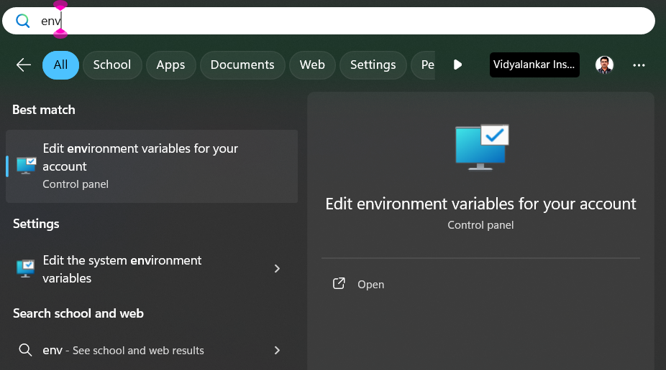

1. Select path variable and click edit

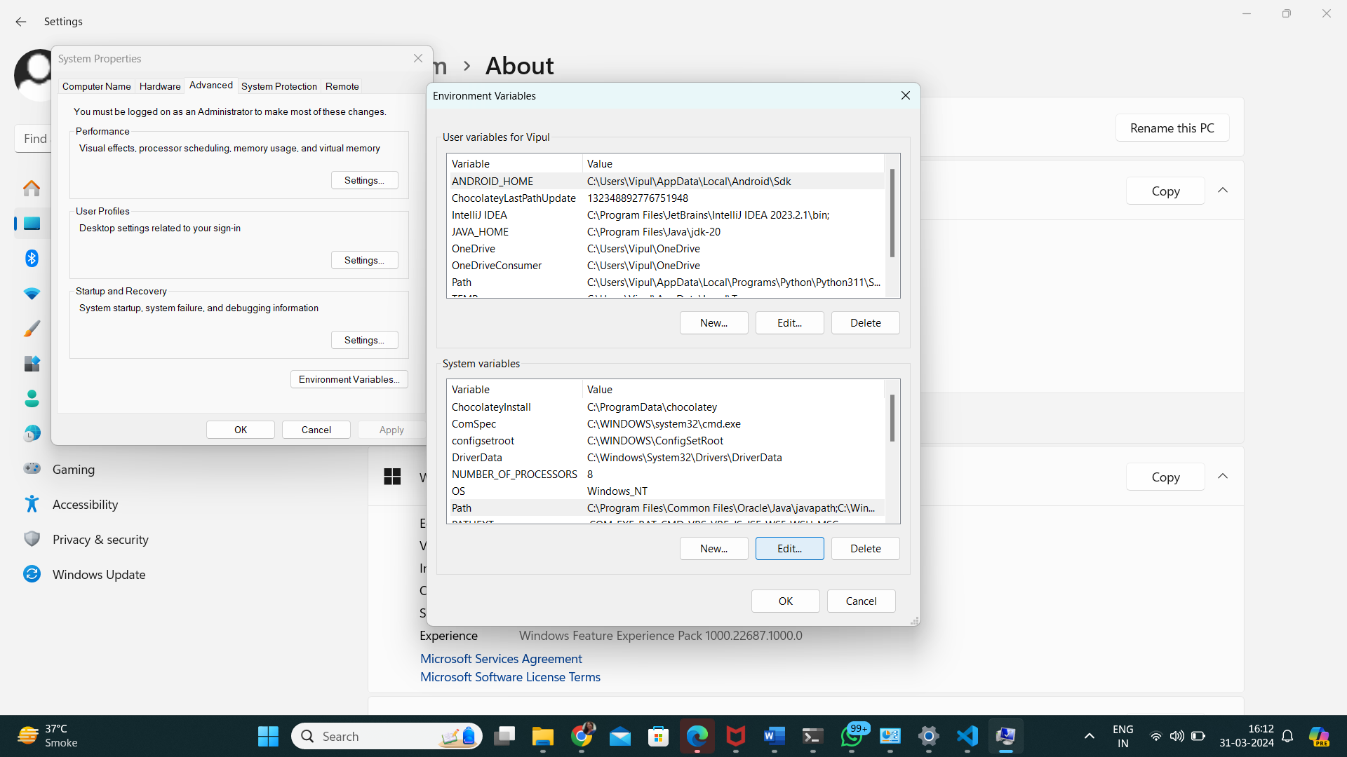

1. Then Click “new”

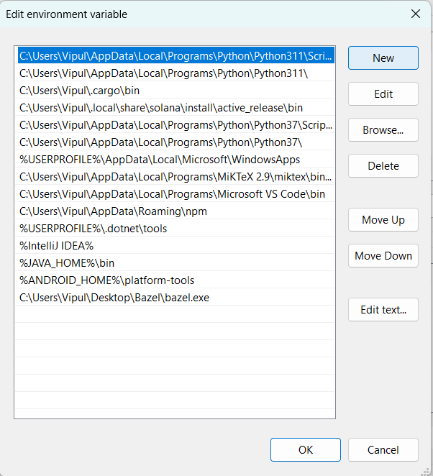

1. Add path to your bazel.exe and click ok twice.

To check the installation is correct, move to the directory where bazel.exe is located and try to run:

bazel version

**2. Integration with Visual studio code**

Install Bazel build extension

